Problem Statement:

● Create a employee table in Mysql and columns as Emp_id, Emp_name, Dept_name(Hadoop Developer), Emp_sal.

● Import the employee table contents into the HDFS directory using Sqoop.

1. Create a database by using the below command:

create database hbase1;

2. To work in the created database, use the following command:

Use hbase1;

3. Create a table employee by using the below command:

create table employee(emp_id INT NOT NULL AUTO_INCREMENT,emp_name VARCHAR(100),emp_sal INT,PRIMARY KEY(emp_id));

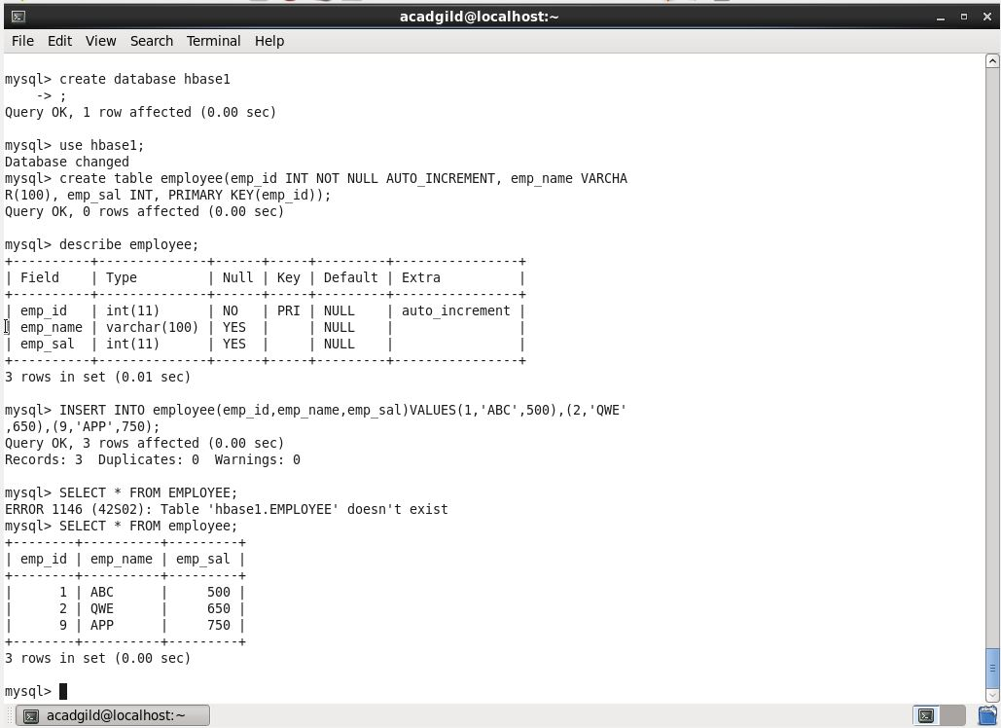

A table has been created with name employee and with the columns emp_id,emp_name,emp_sal. The scheme of this table can be checked using the following command:

describe employee;

The following command can be used to import the table into HDFS.

Syntax:

sqoop import --connect jdbc:mysql://localhost/db_name --username $user_name --password $password --table tbl_name -m1

Here we are connecting to MySQL through JDBC connectors and using the database hbase1. Here it is necessary to specify the MySQL ‘s username and password and the table name.

Here, -m1 at the end of the statement, for each record in the MySQL table we will get separate files in the HDFS.

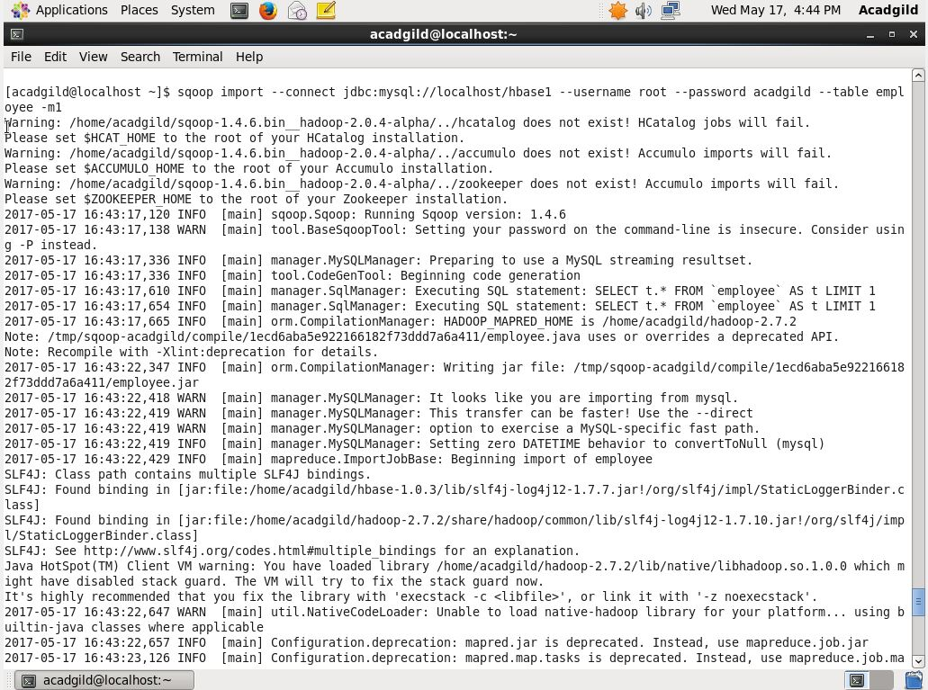

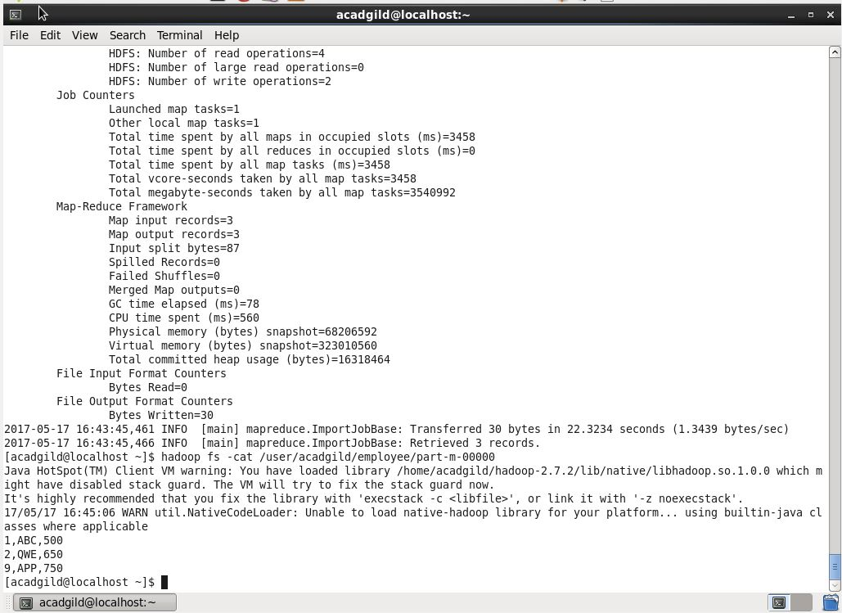

● Create a employee2 table in Mysql and Export employee details file from HDFS directory to Mysql table employee2 using Sqoop.

● Explain the procedures performed, Share the screenshots of commands and results for the same.

Export the input.txt and input2.txt file from HDFS to MySQL

Sqoop calls the JDBC driver written in the –connect statement from the location where Sqoop is installed. The –username and –password options are used to authenticate the user and Sqoop, internally generates the same command against the MySQL instance.

The –table argument defines the MySQL table name, that will receive the data from HDFS. This table must be created prior to running the export command. Sqoop uses the number of columns, their types, and the metadata of the table to validate the data inserted from the HDFS directory. When the export statement is executed, it initiates and creates INSERT statements in MySQl. For example, the export-job will read each line of the input.txt file from HDFS and produces the following intermediate statements.

sqoop export -m 1 –connect jdbc:MySQL://localhost/db1 –username root –password acadgild –table employee2 –export-dir /sqoop_msql/

To obtain a filtered map, we can use the following option:

–input-fields-terminated-by ‘\t’ –MySQL-delmiters

Where ‘\t’ denotes tab.

Once the table inside MySQL and data inside HDFS is ready to be mapped, we can execute the export command.

